**DAILY ONLINE ACTIVITIES SUMMARY**

|  |  |  |  |  |  |  |  |  |
| --- | --- | --- | --- | --- | --- | --- | --- | --- |
| **Date:** | **12-06-2020** | | | | | **Name:** | **Deeksha D Poojary** | |
| **Sem & Sec** | **VIII Semester & A Section** | | | | | **USN:** | **4AL16CS026** | |
| **Online Test Summary** | | | | | | | | |
| **Subject** | | **BDA** | | | | | | |
| **Max. Marks** | | **22** | | **Score** | | | **30** | |
| **Certification Course Summary** | | | | | | | | |
| **Course** | **Introduction to Amazon Elastic Compute Cloud (EC2)** | | | | | | | |
| **Certificate Provider** | | | **Amazon Web Service** | | **Duration** | | | **10 minutes** |
| **Coding Challenges** | | | | | | | | |
| **Problem Statement: Write a program in C to check palindrom or not.** | | | | | | | | |
| **Status: COMPLETED** | | | | | | | | |
| **Uploaded the report in Github** | | | | | **YES** | | | |
| **If yes Repository name** | | | | | **deekshapoojari** | | | |
| **Uploaded the report in slack** | | | | | **YES** | | | |

Online Test Details:

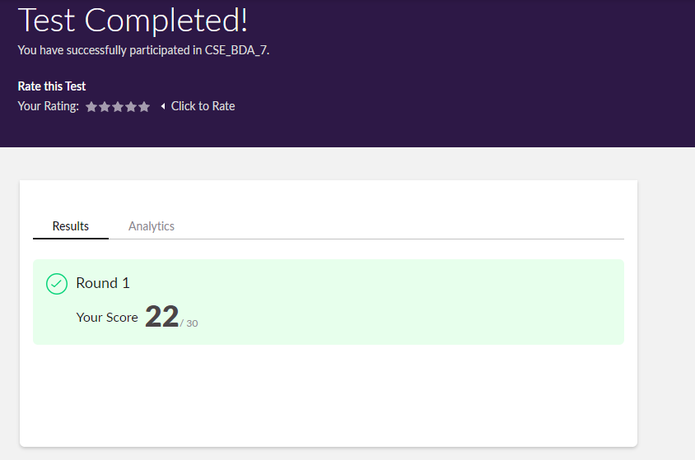

Certification Course 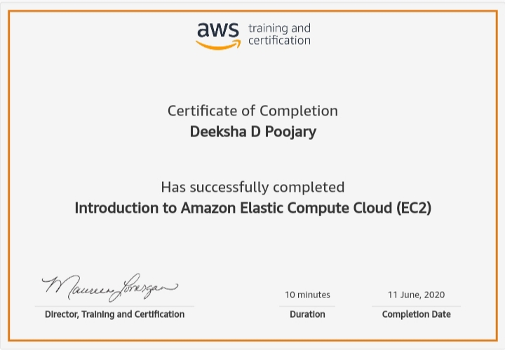Coding Challenges Details:

|  |
| --- |
|  |
|  |
|  |
|  |
|  |
|  |
|  |
|  |
|  |
|  |
|  |
|  |
|  |
|  |
|  |
|  |
|  |
|  |
|  |
|  |
|  |
|  |
|  |
|  |
|  |
|  |
|  |
|  |
|  |
|  |
|  |
|  |
|  |
|  |
|  |
|  |
|  |
|  |
|  |
|  |
|  |
|  |
|  |
|  |
|  |
|  |
|  |
|  |
|  |
|  |
|  |
|  |
|  |
|  |

**Program1:**

|  |  |
| --- | --- |
|  |  |

**#include <stdio.h>**

**int main() {**

**int n, reversedN = 0, remainder, originalN;**

**printf("Enter an integer: ");**

**scanf("%d", &n);**

**originalN = n;**

**// reversed integer is stored in reversedN**

**while (n != 0) {**

**remainder = n % 10;**

**reversedN = reversedN * 10 + remainder;**

**n /= 10;**

**}**

**// palindrome if orignalN and reversedN are equal**

**if (originalN == reversedN)**

**printf("%d is a palindrome.", originalN);**

**else**

**printf("%d is not a palindrome.", originalN);**

**return 0;**

**}**